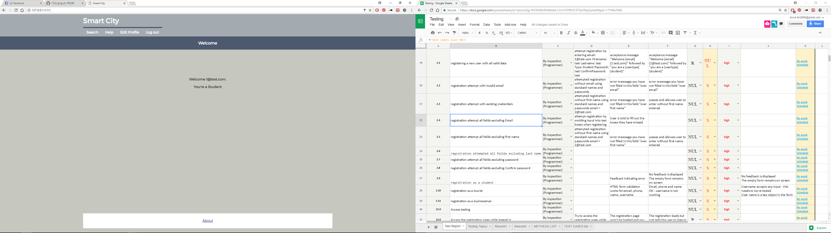2.1 registering a new user with all valid data

2.2 registration attempt with invalid email

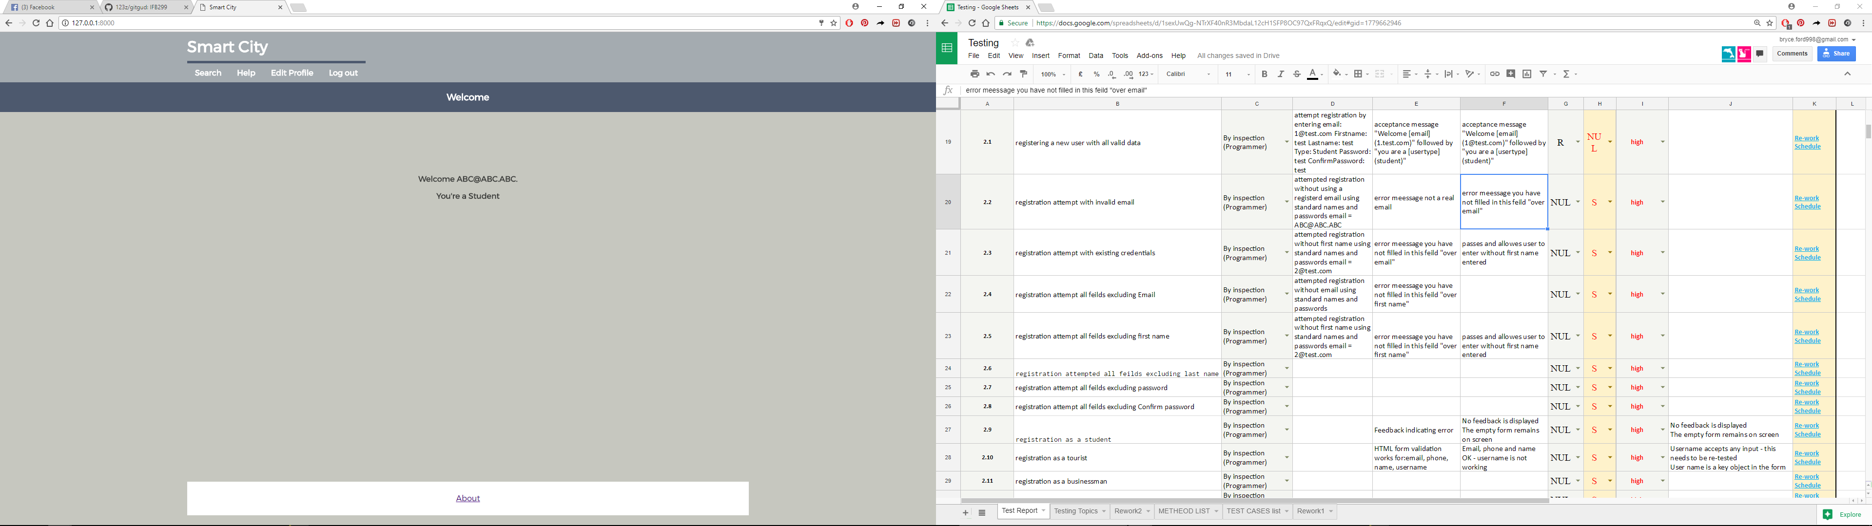

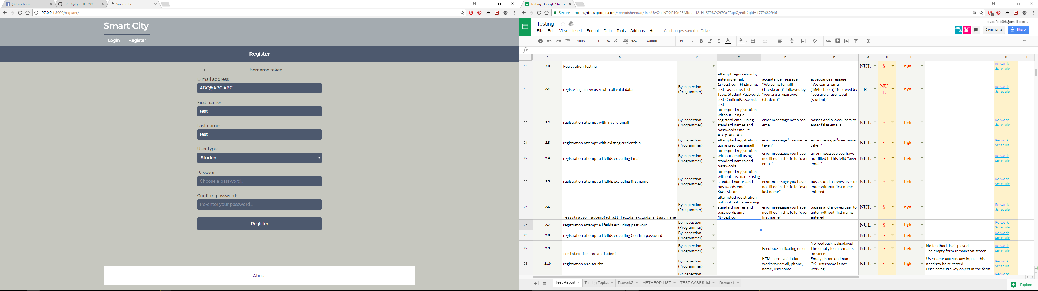2.3 registration attempt with existing credentials

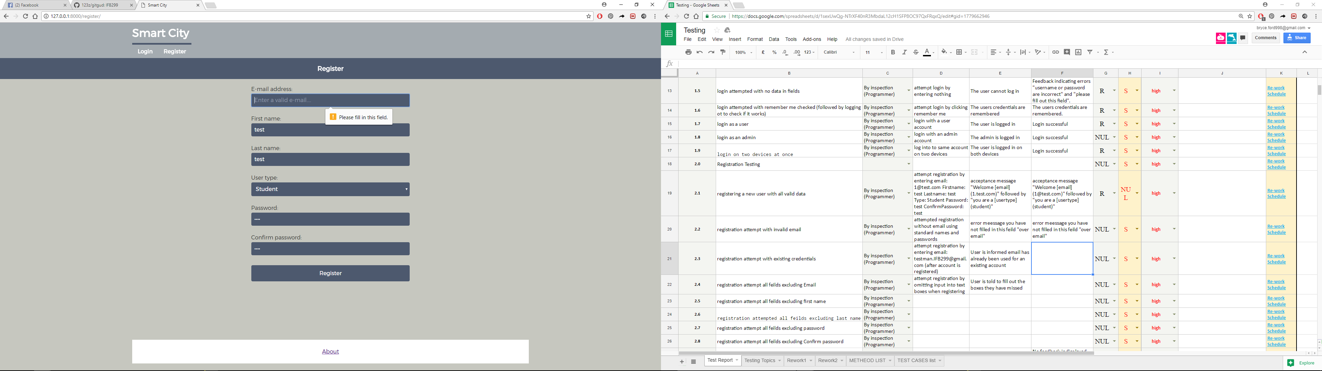2.4 registration attempted all fields excluding email

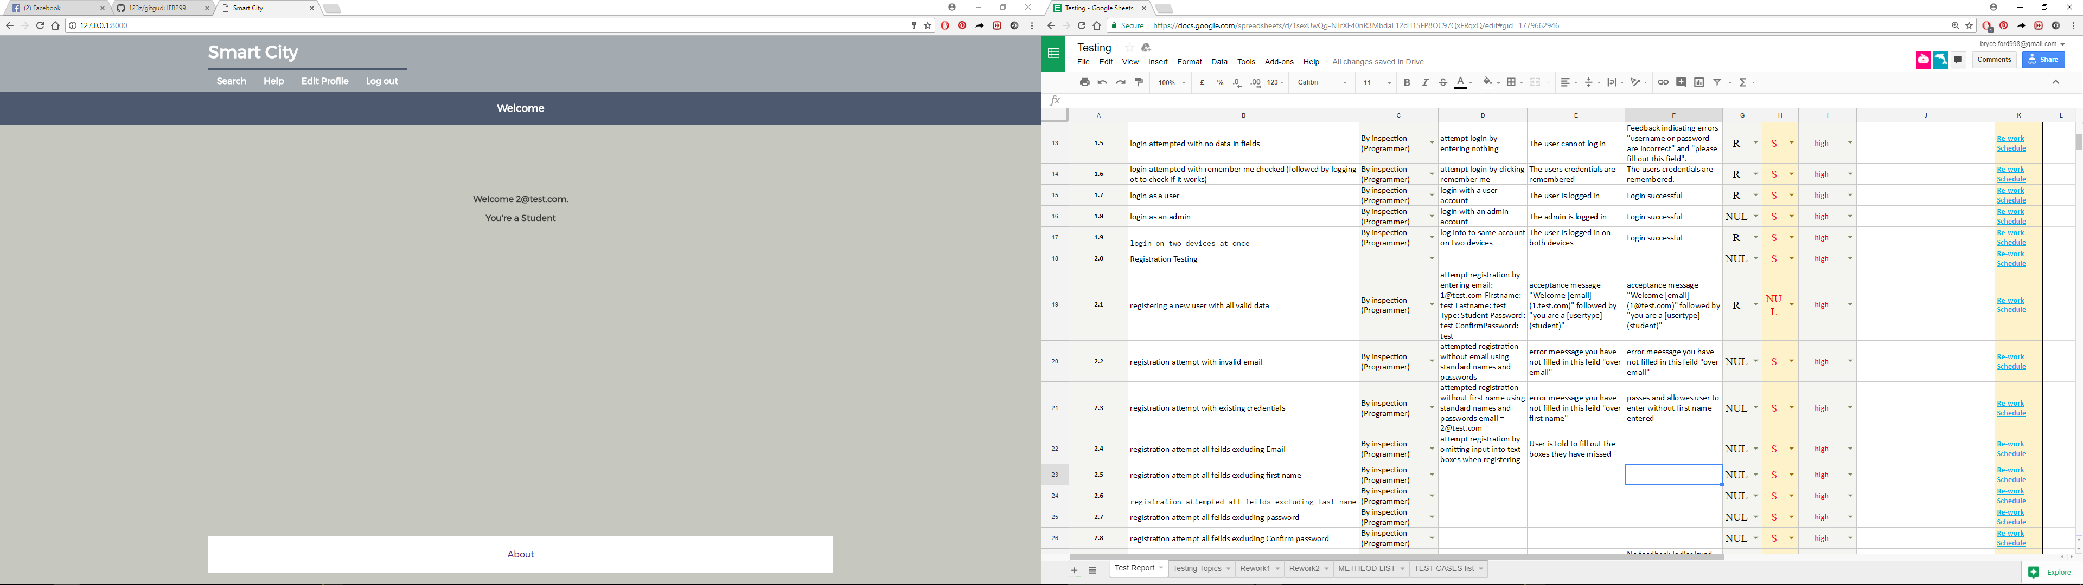2.5 registration attempt all fields excluding first name

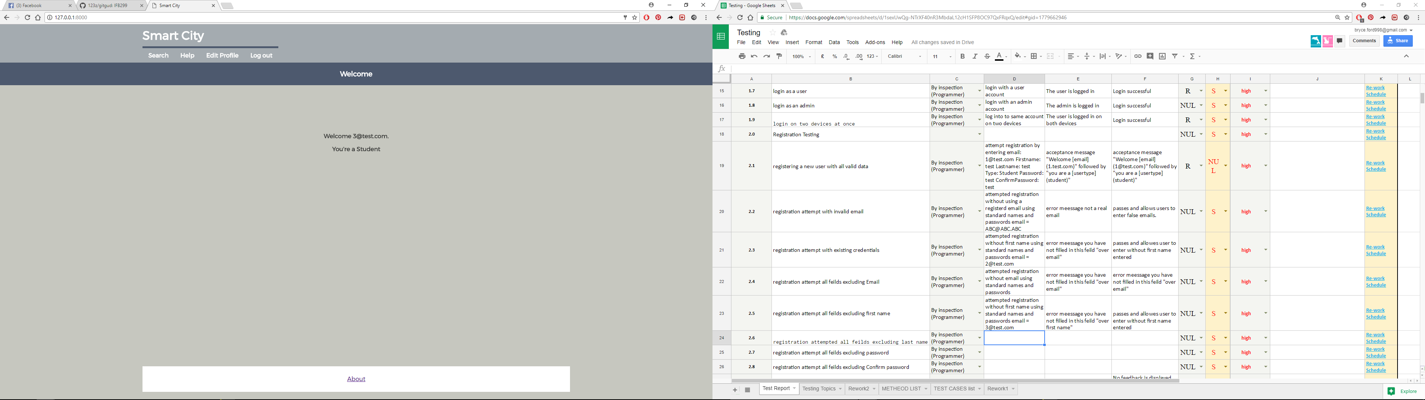2.6 registration attempted all fields excluding last name

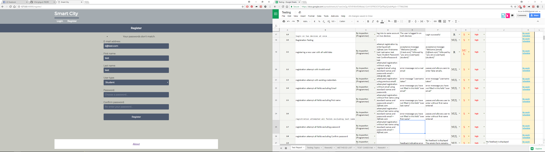2.7 registration attempted all fields excluding password

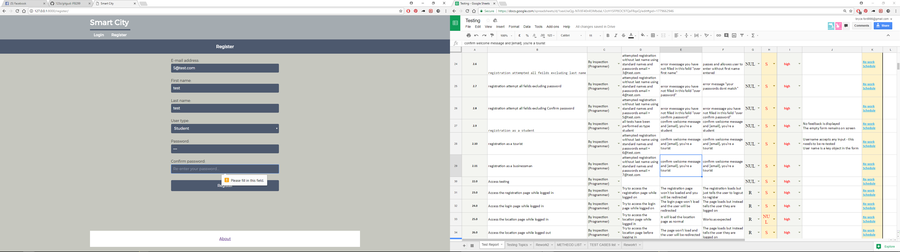2.8 registration attempted all fields exclude confirm password

2.9 registration as a student

2.10 registration as a tourist

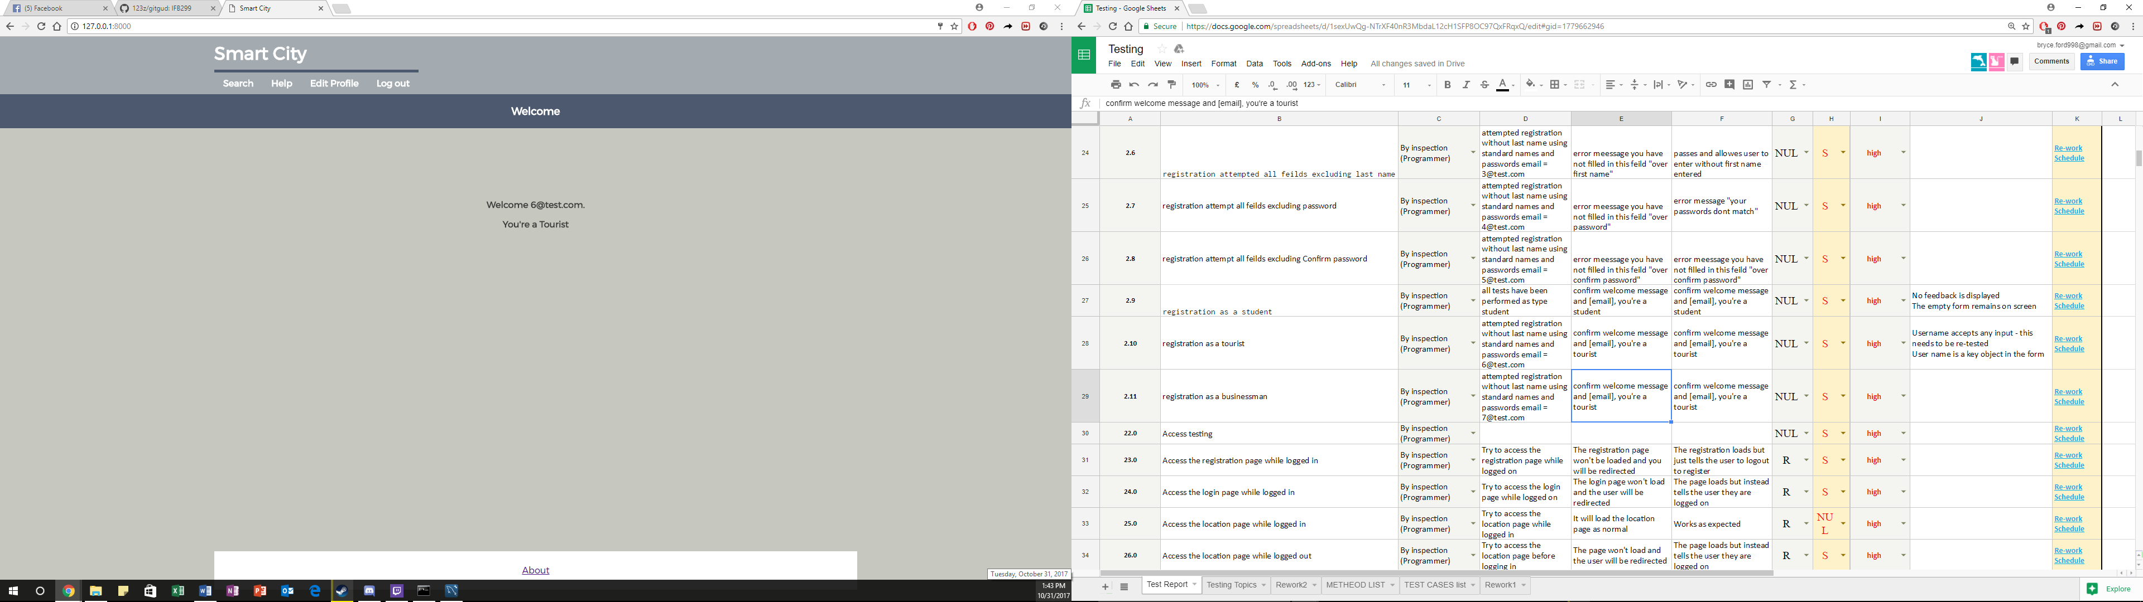

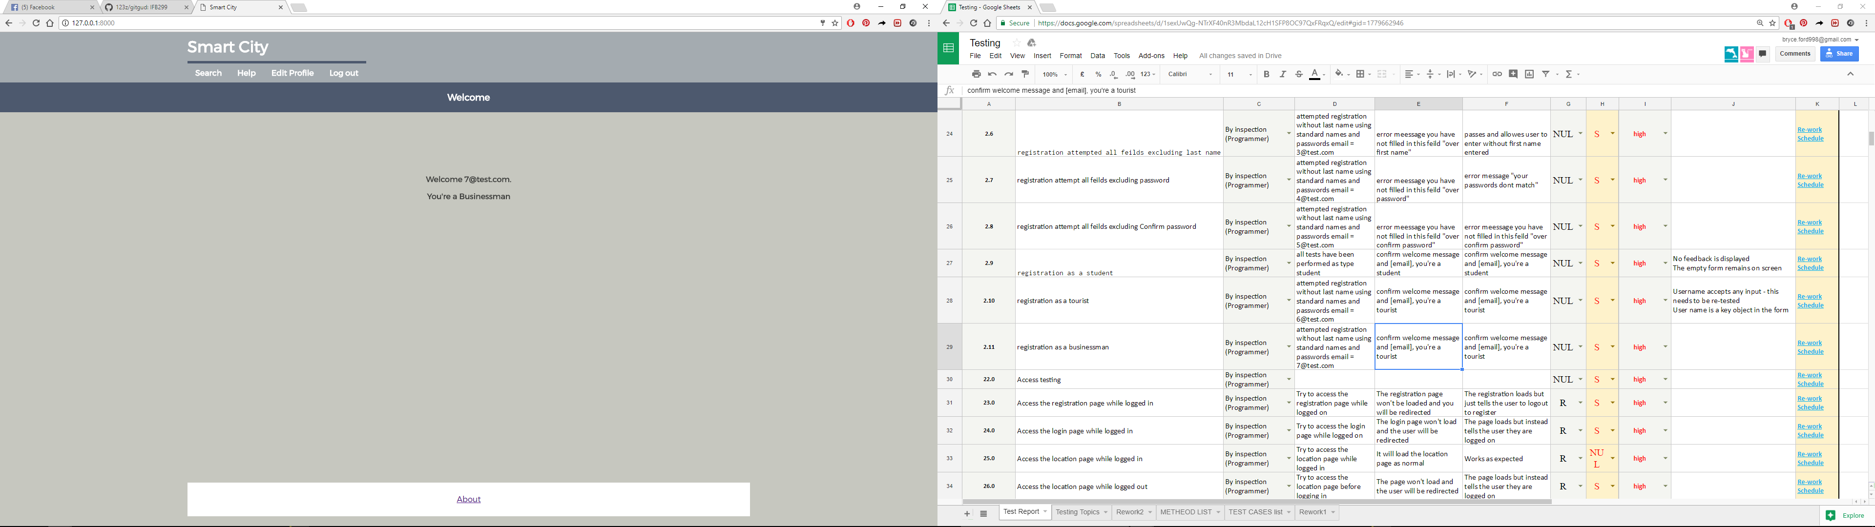2.11 registration as a businessman